

STATEMENT OF ADVICE

Financial Planning Strategy

Prepared for:
D’Wayne & Kate Leonard
Of

2 Hampshire Place PROSPECT TAS 7250

Prepared on:

31st of July 2025

By your Adviser:

Tristan Biro G Dip FS (Fin Plan)

Lakeside Financial

Suite 201, 429 Bay Street
Brighton VIC 3186

Ph: 03 9596 5111 Fax: 03 9596 3222

Email: Tristan.biro@lakesidefinancial.com.au

Authorised Representative # 1313019
Pareto Group Pty Ltd
ABN 11 155 278 078 Australian Financial Services Licensee No. 418700
1/99 Bay Street, Brighton, Vic, 3186
What this document is about
This Statement of Advice (or SoA) is an import document.
- It provides you with information about our advice so you can make a decision about implementing the advice.
- It should be read in conjunction with other documents such as Product Disclosure Statements and our Financial Services Guide.

What to do after reading this Statement of Advice
Please contact us.
- If you have any questions.
- If we have omitted, overlooked or incorrectly understood any of your relevant circumstances.
- When you are ready to implement the recommendations.
- Or, if you decide you want to do something else and need our advice or assistance.
Ph: 03 9596 5111 Fax: 03 9596 3222

31st of July 2025

D’Wayne & Kate Leonard
2 Hampshire Place PROSPECT TAS 7250

Dear D’Wayne & Kate Leonard,

I am pleased to enclose your Statement of Advice (SoA).

It is an important document that you should read and understand before making a decision to proceed further.

We have based the strategies and recommendations in this document on our understanding of your current personal and financial position. If any of this information does not reflect any part of your current position, goals and objectives please advise us immediately and we will make the necessary changes.

The SoA sets out our recommended strategies to address your needs, together with a recommended course of action to implement these strategies.

When you are ready to proceed, we would be very happy to help you with the implementation of the advice, including the completion and lodgement of application forms and other documents.

Please note, our recommendations in this Statement of Advice are valid for 30 days from the date on the cover of this document. If your circumstances change before you implement our recommendations, or if you don’t act on them within 30 days, they may no longer be appropriate for you. If that happens, please ask us to review your situation again before you take any action.

Once implemented, we should review your situation on a regular basis to ensure we make the most of any changes that may impact on the strategies I have recommended for you.

Yours sincerely,

Tristan Biro
G Dip FS (Fin Plan)
Authorised Representative No 1313019 of
Pareto Group Pty Ltd

Purpose of this document

The following Statement of Advice (SoA) is an outline of the financial plan discussed with your financial planner. It details the recommendations needed to execute your plan and achieve your financial objectives.

Timeframe for our advice

Our recommendations in this SoA are valid for 30 days from the preparation date on the cover of this document. If your circumstances change before you implement our recommendations, or if you don’t act on them within 30 days, they may no longer be appropriate for you. If that happens, please ask us to review your situation before taking any action.

Check for accuracy

This SoA is based on the information you provided. Please read the document carefully, checking that your details are correct and that no import facts are missing. If anything is wrong or missing, please let us know immediately—otherwise our advice may be based on incorrect information and may not be right for you.

Limitations of our advice

We cannot give advice on:
- Trust or business structures | - Direct share or property purchases
- Taxation | - Legal matters
- General insurance

Please don’t consider any of this document’s recommendations to be advice in any of these areas. If you need advice in these areas, please see a qualified professional in that field.
Assumptions we've made

When giving advice, we make certain assumptions to demonstrate how the advice could affect your financial situation. We've based our advice on economic information and legislation that was current when we prepared your SoA.

All dollar amounts in this SoA are in today’s dollars, even when we mention future income, expenses, investment amounts and so on. Naturally we can’t predict what future inflation rates will be, so we can only make assumptions based on past trends. Also, all amounts listed in this document are “p.a.” (per annum) unless otherwise stated or implied.

Product selection

We are committed to giving you the best products for your situation. When preparing your advice, we considered and recommended only those products on Pareto Group’s “Approved Product List”. This list was compiled by a dedicated Investment Review Committee, which regularly reviews it. To see the complete product list, please ask us.

Introduction
You are entitled to receive a Statement of Advice (SoA) whenever we provide you with any personal financial advice. Personal financial advice is advice that takes into account any one or more of your objectives, financial situation and needs.

This SoA is a record of the personal financial advice provided to you and includes information on the basis on which this advice is given, information about remuneration including fees, any other benefits and any interests, relationships or associations which might influence the making of the advice.

If this advice includes a recommendation to you to acquire a particular financial product (other than securities) or an offer to issue or arrange the issue of a financial product to you, we will also provide you with a Product Disclosure Statement containing information about the particular product to help you make an informed decision about that product.

The Scope of Our Advice

In this statement of advice, the main-focus is on:

- Superannuation advice
- Superannuation contribution strategies
- Retirement Outcome
- Trauma claim payout allocation strategies

This advice is based on information we have obtained from you. You must ensure the information is accurate and complete. Otherwise, this advice may be based on inaccurate or incomplete information relating to your investment objectives, financial situation or needs. You must therefore assess whether the advice is appropriate, in the light of your own individual investment objectives, financial situation or needs.

You recognise in each of the areas of advice we provide, we only provide advice to the extent we are able to under the relevant legislation.

Our Investment Recommendations

In respect of the specific investments, we recommend as part of our advice you are entitled to a 14-day cooling off period for your initial investment. A cooling off period generally means a period of time after which you have provided your capital for investment, where you can change your mind and request for your capital to be returned to you.

Each fund manager or investment provider may implement the cooling off period in a slightly different manner. Therefore, we recommend you refer to the Product Disclosure Statement for each of the recommended investments in order to understand the operation of each provider’s cooling off period.

Your Adviser

At any time should you have any questions or concerns, in the first instance please contact your adviser Tristan Biro on (03) 9596 5111.

Tristan Biro is authorised to represent Pareto Group Pty Ltd. Should you wish to discuss matters of concern about your adviser or the advice you have received please contact us on 03 9596 5111.

The Planning Process

D’Wayne & Kate Leonard, Financial Planning is a process to help you reach both your Personal and Financial Goals and Objectives. In order to achieve this, we jointly need to undertake a number of tasks, including:

- Confirm your personal goals and lifestyle objectives;
- Quantify the resources required to meet your goals and objectives;
- Identify any gaps in your current plans and your stated goals and objectives;
- Develop suitable strategies to address any differences that may exist bearing in mind your attitude to investing and your risk profile;
- Conduct a regular review of the strategies we put into effect to ensure they keep pace with your changing needs, legislative changes and the investment environment.

Executive Summary

In this plan our advice considers the following areas of your financial circumstances.

Your Goals and Objectives

After our discussions I have listed below what we agreed were your key goals and objectives. The points listed below form the basis of the plan I have prepared, and therefore you should read them carefully now to ensure that we have an accurate foundation on which to proceed. If there are any modifications required, please advise us prior to the commencement of your financial plan.

Your goals and objectives are to:

- Explore the benefits of Superannuation.
- Wealth Accumulation strategies.
- Preserve your existing capital.
- Explore options regarding your Trauma Claim Payout.
- Long term wealth projections.

Personal Information

During our discussions and from the information you have provided, your Personal Details can be summarised as follows:

Personal Details
Title | Mr | Mrs
First Name | D’Wayne | Kate
Surname | Leonard | Leonard
Gender | Male | Female
Date of Birth | 01/08/1979 (45) | 20/02/1979 (46)
Marital Status | Married | Married

Employment Details
Employment Status | Part-Time / Work Cover | Full-Time
Occupation | Patient Transport Officer | Pharmacy Manager
Employer | Dept. of Health | Priceline / Hans Wanders

Estate Planning
 |  | D’Wayne Leonard |  | Kate Leonard
Do you have a Current Will? |  | No |  | No
Do you have Current Powers of Attorney? |  | No |  | No
Do you have a Testamentary Trust? |  | No |  | No

Current Assets and Liabilities
The following is an Asset and Liabilities summary that estimates your current Net Worth position based on the information provided.
ASSETS
Lifestyle Assets | Value
Principal Place of Residency  Home Contents  Motor Vehicles | $720,000  $300,000  $62,300
Total Lifestyle Assets | $1,082,300

Investment Assets | Value
Cash  Trauma Claim Payout | $26,205  $620,000
Total Investment Assets | $646,205

Superannuation Assets
D’Wayne Rest Super  D’Wayne Care Super  Kate Care Super | $165,926  $60,527  $210,064
Total Superannuation Assets | $436,517

Total ASSETS | $2,165,022

LIABILITIES
ANZ Mortgage | $242,837
Total Liabilities

NET WORTH | $1,922,185

Notes: As the above information has been used in preparing our recommendations, please advise us of any errors or omissions. The ‘Total’ column indicates the value of assets and liabilities which are owned by you. This report does not show the value of any portion of the asset or liability that may be owned by a third party or associated entity.

Your Investor Risk Profile
The following section of your plan helps to ensure that I clearly understand your attitude to investment selection. Additionally, investments contain various characteristics, which may or may not suit each individual investor.

D’Wayne & Kate, based upon your answers to the Investor Risk Profile questionnaire, it was determined that you can be classified as a ‘Balanced’ investor.

Typically, a Balanced investor has the following characteristics:

- A Balanced investor places greater emphasis on capital appreciation with current income and asset preservation being of a secondary concern.

- This requires an investments time horizon of between 5 – 7 years.

- A Balanced portfolio would typically comprise an overweight holding in shares and property with a small exposure to income bearing securities such as cash and fixed interest.

A ‘Balanced’ investor will typically diversify their investment in the following manner:

Australian Shares 27%
International Shares 29%
Fixed Interest 26%
Property 12%
Cash 6%

Our research indicates that long term returns will be best achieved through a diversified portfolio covering all major asset classes (i.e. Cash, Fixed Interest, Shares, Index Shares and Property).

By covering all primary investment markets, the risks and volatility of your investments can be managed to levels consistent with your investment profile, whilst maintaining the potential for long term growth.

If you feel the above investor profile does not reflect your attitude as an investor, or the recommended portfolio contained in this report is too aggressive or conservative, please let me know so I may adjust my recommendations accordingly.

Strategy Recommendation

Tax Rates
When assessing the most tax effective environment for your investment assets, we need to consider the tax that would be payable on any income that these investments will generate. The current tax rates are as follows:

D’Wayne Income Earned in your personal name - $61,621

Kate Income Earned in your personal name - $72,652

Tax rates 2025-26
Taxable income | Tax on this income
$1 – $18,200 | Nil
$18,201 – $45,000 | 16c for each $1 over $18,200
$45,001 – $135,000 | $4,288 plus 30c for each $1 over $45,000
$135,001 – $190,000 | $31,288 plus 37c for each $1 over $135,000
$190,001 and over | $51,638 plus 45c for each $1 over $190,000
* The above rates do not include the Medicare levy of 2.0%.

Income Earned in the superannuation environment
Superannuation in ‘accumulation’ phase - Tax rate = 15%
Superannuation in ‘pre-retirement pension’ phase - Tax rate = 15%
Superannuation in ‘allocated pension’ phase - Tax rate = 0%

Tax on superannuation earnings, contributions and income streams

 | Non-superannuation | Super accumulation and pre-retirement pension phase | Super allocated pension phase
 |  |  | After age 60
Salary/pension income | Marginal tax rate (max 45% + medicare) | n/a | Tax free
Super contributions (SGC, salary sacrifice) | n/a | 15% | n/a
Investment income | Marginal tax rate (max 45% + medicare) | Maximum 15% | Tax free*
Capital gains | Marginal tax rate (50% discount if held for more than 12 months) | 10% (15% if asset held less than 12 months) | Tax free*

Superannuation Contribution Limits

Table 1- Concessional contribution limits

Concessional contributions include employer and self-employed contributions such as salary sacrifice, superannuation guarantee and personal concessional contributions.

Date | Limit (per annum)
 | To Age 49 | Age 50-59 | Age 60-67 | Age 68-74* | Age75 and over
From 1 July 2017 | $25,000 | $25,000 | $25,000 | $25,000 | SGC only
From 1 July 2021 | $27,500 | $27,500 | $27,500 | $27,500 | SGC only
From 1 July 2022 | $27,500 | $27,500** |  |  | SGC only
From 1 July 2024 | $30,000 | $30,000** |  |  | SGC only
From 1 July 2025 | $30,000 | $30,000** |  |  | SGC Only

*Must be employed at least 40 hours during any consecutive 30-day period in the financial year you would like to make the contributions.
** From 1/07/2022, work test requirements were removed for all contributions, except personal tax-deductible contributions.

Table 2 - Non-concessional contribution limits

Date | Limit on after-tax contributions | Eligibility Requirements
 |  | Under age 67 | Age 67 to 74 | Age 75 and over
From  1 July 2017 | $100,000 p.a. | May bring forward two years of contributions to make a $300,000 contribution in one financial year | Must be employed | Cannot contribute
From  1 July 2021 | $110,000 p.a. | May bring forward two years of contributions to make a $330,000 contribution in one financial year | Must be employed | Cannot contribute
From  1 July 2022 | $110,000 p.a. | May bring forward two years of contributions to make a $330,000 contribution in one financial year |  | Cannot contribute
From 1 July 2024 | $120,000 p.a. | May bring forward two years of contributions to make a $360,000 contribution in one financial year |  | Cannot contribute
From 1 July 2025 | $120,000 p.a. | May bring forward two years of contributions to make a $360,000 contribution in one financial year |  | Cannot contribute

Summary Of Non-Concessional Contribution Rules

Non-concessional contributions (sometimes referred to as after-tax contributions) are generally those that are:
- Made from after tax money (and don’t provide the contributor with a tax-deduction), and
- Not taxed when received by the superannuation fund (i.e. not included in the fund’s assessable income).

Standard Non-Concessional Contributions Cap

The standard non-concessional cap is set at four times the basic concessional contributions cap, which is indexed at Average Weekly Ordinary Time Earnings (AWOTE) in increments of $2,500. Therefore, the standard non-concessional contributions cap will increase in line with increases in the concessional contributions cap, in increment of $10,000.

In addition, a member’s total superannuation balance just prior to the start of a financial year must be less than the general transfer balance cap for the financial year ($1.9 million for 2024-25) to access the standard non-concessional cap - where this is not the case the member’s non-concessional cap for the financial year will be nil.

The standard non-concessional cap and total superannuation balance requirement is shown in the table below.

Financial Year | Standard non-concessional contributions cap | If total superannuation balance is:
2025-26 | $120,000 | Less than $1.9 million at 30 Jun 2025
 | Nil | $1.9 million or more at 30 June 2025
2024-25 | $120,000 | Less than $1.9 million at 30 Jun 2024
 | Nil | $1.9 million or more at 30 June 2024
2023-24 | $110,000 | Less than $1.9 million at 30 Jun 2023
 | Nil | $1.9 million or more at 30 June 2023
2022-23 | $110,000 | Less than $1.7 million at 30 Jun 2022
 | Nil | $1.7 million or more at 30 June 2022
2021-22 | $110,000 | Less than $1.7 million at 30 June 2021
 | Nil | $1.7 million or more at 30 June 2021
2020-21 | $100,000 | Less than $1.6 million at 30 June 2020
 | Nil | $1.6 million or more at 30 June 2020

Concessional Superannuation Contributions Carry Forward

The concessional superannuation contribution cap in previous years was $25,000 per annum. In the 2021/22 financial year, this cap increased to $27,500 p.a. In the 2024/25 financial year, this cap increased again to $30,000 p.a.

Carry Forward Concessional Contributions:

- If you have a total superannuation balance below $500,000 you can carry forward any unused concessional contributions cap amounts that accrue from 1 July 2019 for up to five financial years. This allows eligible members who do not use all of their concessional cap in a particular financial year, to carry forward their unused concessional cap amounts to future years.
- To be eligible to make catch-up concessional contributions in a year, you must meet the following conditions:
  - have a ‘total superannuation balance’ of less than $500,000 as at 30 June at the end of the financial year immediately preceding the financial year in which the concessional contribution is to be made
  - have previously unused concessional contributions cap amounts that have accrued in one or more of the five financial years preceding the year in which the concessional contribution is made.

Benefits:

- Personal concessional contributions are made with pre-tax dollars and therefore you will receive a reduction in taxable income for the contributions that you make.

Downsizer Contributions

2Currently, individuals of age 55 and over are able to contribute an amount equal to all or part of the sale proceeds from the sale of their main residence, of up to $300,000 each into super. Downsizer contributions can be made regardless of the other contributions caps and restrictions that might apply to making voluntary contributions, i.e. age restrictions or work test requirements. There is no upper age limit on making downsizer contribution.

A member satisfies eligibility requirements if:

- The contributor is 55 years of age or over at the time of the contribution.
- The contribution is capped at $300,000 per person.
- The main residence was owned by the individual, spouse or former spouse for 10 or more years prior to the sale.
- The contribution must be made into the fund within 90 days of the change of ownership.

Benefits:
- Any assets held within the fund are effectively being held in the most tax effective environment.
- The returns on balances held within superannuation and invested should be higher than the current returns on cash held in bank deposits.
Risks:
- Superannuation benefits are subject to market returns and earning rates are not guaranteed.

Superannuation Funds

D’Wayne & Kate, you currently have the following superannuation funds:

D’Wayne

Rest Super – Account Number 104473383
- The fund currently has a balance of approximately $165,926.

Care Super – Account Number SPRN273367
- The fund currently has a balance of approximately $60,527.

Kate

Care Super – Account Number SPRN154006
- The fund currently has a balance of approximately $210,064.

Investments Within Superannuation

Rest Super – Account Number 104473383 (D’Wayne)
D’Wayne, you have a superannuation fund with Rest invested in the ‘Rest Super – Growth Option’ option.

This option invests in a mix of asset classes with an emphasis on shares, property, and infrastructure.
The asset allocation of your Rest portfolio is:
Asset Class | % of Portfolio
Australian Shares | 23.5%
International Shares | 35.0%
Property / Infrastructure | 9.0%
Alternatives (Growth) | 11.0%
Alternatives (Defensive) | 2.5%
Fixed Interest | 14.5%
Cash | 4.5%
 | 100%

Historical Performance (Net of Fees)
Recent net returns (after investment fees and taxes) for the Rest Super Growth option have been strong, reflecting solid long-term performance. As of the most recent reporting date (30 June 2025), the fund’s 1-year, 3-year, and 5-year annualized returns were:

Period (to 30 Jun 2025) | Net Return (per annum)
1-year | 9.85%
3-year (p.a.) | 9.26%
5-year (p.a.) | 8.38%

These returns are net of investment fees and costs (and after taxes), meaning the performance shown is what was actually credited to members’ accounts (excluding only administration fees). All figures are annualized for multi-year periods (e.g. the 3-year and 5-year figures represent average annual returns per year over those periods)

Care Super – Account Number SPRN273367 (D’Wayne)
D’Wayne, you have a superannuation fund with Care Super invested in the ‘Balanced (MySuper)’ option.

This option invests in a mix of asset classes with an emphasis on shares, property, and infrastructure.

The asset allocation of your Care Super Balanced portfolio is:

Asset Class | % of Portfolio
Australian Shares | 23.0%
International Shares | 26.0%
Property / Infrastructure | 20.0%
Alternatives (Growth) | 5.0%
Alternatives (Defensive) | 11.0%
Fixed Interest | 8.0%
Cash | 7.0%
 | 100%

Historical Performance (Net of Fees and Taxes)

Recent net returns (after investment fees and taxes) for the Care Super Balanced option have been strong, reflecting solid performance over the long term. As of the most recent reporting date (30 June 2025), the fund’s 1-year, 3-year, and 5-year annualized returns were approximately:
Period (to 30 Jun 2025) | Net Return (per annum)
1-year | 8.58%
3-year (p.a.) | 8.72%
5-year (p.a.) | 8.22%

Kate

Care Super – Account Number SPRN154006 (Kate)

Kate, you have a superannuation fund with Care Super (and D’Wayne also has a smaller balance in the same fund) invested in the ‘Balanced (MySuper)’ option.

This option invests in a mix of asset classes with an emphasis on shares, property, and infrastructure.

The asset allocation of your CareSuper Balanced portfolio is:
Asset Class | % of Portfolio
Australian Shares | 23.0%
International Shares | 26.0%
Property / Infrastructure | 20.0%
Alternatives (Growth) | 5.0%
Alternatives (Defensive) | 11.0%
Fixed Interest | 8.0%
Cash | 7.0%
 | 100%

Historical Performance (Net of Fees)

Recent net returns (after investment fees and taxes) for the Care Super Balanced option have been strong, reflecting solid performance over the long term. As of the most recent reporting date (30 June 2025), the fund’s 1-year, 3-year, and 5-year annualized returns were approximately:

Period (to 30 Jun 2025) | Net Return (per annum)
1-year | 8.58%
3-year (p.a.) | 8.72%
5-year (p.a.) | 8.22%

Super Projections Based on Current Trajectory

Based on a more conservative long-term assumption of 7% annual net growth, the following projections show how your super balances could grow over time in 5-year increments. (For context, the long-term average return of Australian superannuation funds is about 7.2% p.a., so this projection aligns with industry expectations.)

Projected Superannuation Balances for D’Wayne and Kate (at 7% Growth)
Based on a more conservative long-term assumption of 7% annual net growth, the following projections show how your super balances could grow over time in 5-year increments. (For context, the long-term average return of Australian superannuation funds is about 7.2% p.a., so this projection aligns with industry expectations.)

D’Wayne’s Super Projection
Current combined balance (Rest + CareSuper): $226,453
Assuming 7% annual growth and no additional contributions:
Year (Age) | Projected Balance
2030 (Age 51) | ~$317,000
2035 (Age 56) | ~$445,000
2040 (Age 61) | ~$624,000
2045 (Age 66) | ~$875,000

Kate’s Super Projection
Current balance: $210,064
Assuming 7% annual growth and no additional contributions:
Year (Age) | Projected Balance
2030 (Age 50) | ~$295,000
2035 (Age 55) | ~$414,000
2040 (Age 60) | ~$581,000
2045 (Age 65) | ~$815,000

Key Observations
- Over 20 years, D’Wayne’s balance could almost quadruple (from $226k to ~$875k).
- Kate’s balance follows a similar trajectory, reaching ~$815k by age 65.
- Combined, your projected super could approach $1.7 million by retirement (age 65).

Assumptions
- Growth Rate: 7% p.a. (net of fees and taxes)
- Inflation-Adjusted: Projections shown in today’s dollars
- No new contributions included (in reality, contributions would significantly boost balances)
- No withdrawals or major strategy changes
- Past performance is not a reliable indicator of future results

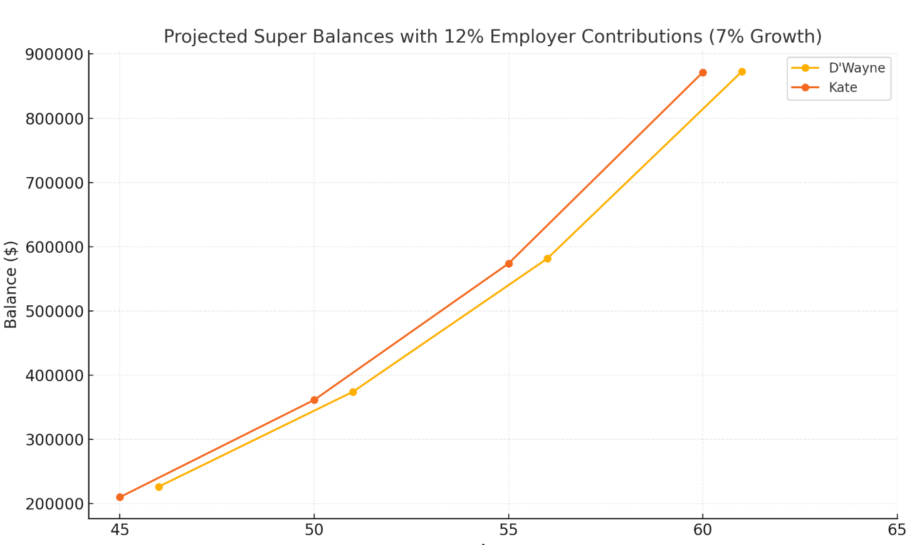

Maximising Concessional Contribution Cap

Employer Contributions
- D’Wayne: Gross Estimation - $71,500 × 12% = $8,580
- Kate: Gross Estimation - $94,000 × 12% = $11,280

Remaining Cap for Personal Contributions
- D’Wayne: $30,000 – $9,360 = $21,420
- Kate: $30,000 – $11,280 = $18,720

Tax Impact
D’Wayne
- Additional contribution: $21,420
- Marginal tax rate (incl. Medicare): 32% (30% + 2%)
- Tax saving: $21,420 × 32% = $6,854
- Less contributions tax (15%): $21,420 × 15% = $3,213
- Net benefit: $3,641
- Extra super invested: $21,420

Kate
- Additional contribution: $18,720
- Tax saving: $18,720 × 32% = $5,990
- Less contributions tax (15%): $18,720 × 15% = $2,808
- Net benefit: $3,182
- Extra super invested: $18,720

Person | Max Personal Contribution | Tax Saving | Contributions Tax | Net Benefit
D’Wayne | $21,420 | $6,854 | $3,213 | $3,641
Kate | $18,720 | $5,990 | $2,808 | $3,182

Combined Outcome
- Additional invested in super: $40,140
- Combined net tax savings: $6,823
- Effective tax advantage: Moving taxable income taxed at 32% into super taxed at 15%.

If you were to make the maximum allowable concessional contributions ($30,000) over the next five years, your projected superannuation balances would be as follows:

Age | D’Wayne (SGC Only) | D’Wayne (Max 5 Yrs) | Kate (SGC Only) | Kate (Max 5 Yrs)
Now | $226,453 | $226,453 | $210,064 | $210,064
51 | $358,352 | $481,319 | $359,494 | $467,148
56 | $554,415 | $727,680 | $569,077 | $720,067
61 | $830,228 | $1,072,004 | $863,029 | $1,074,800
66 | $1,217,056 | $1,556,491 | $1,275,311 | $1,572,331

Mortgage Strategy

You currently have a home loan with the following details:
Loan Provider | Loan Balance | Interest Rate | Repayment
ANZ | $242,837 | 5.97% (Variable) | $1,433 p.m.
Importantly, your loan is fully offset by the Trauma payout, which means you are not paying any interest on this loan.

Annual Interest Savings
If the offset account were not in place, the interest charged would be approximately:
- $242,837 × 5.97% = $14,499 p.a.
By maintaining a fully offset position, you are saving around $14,500 each year in interest costs.

Opportunity for Strategic Use of Offset Funds
With your loan fully offset, the funds in your offset account are now effectively idle from a return perspective. These monies can now be strategically redirected to support your broader financial goals, such as:

✔ Funding Education Costs – Assisting your children with study-related expenses while they are in Melbourne.
✔ Superannuation Contributions – Making additional concessional contributions to super could deliver significant tax benefits and boost your retirement savings.
(For example, by contributing these funds to super under the concessional cap, you may receive an immediate tax benefit and achieve long-term compounding growth.)

Property Strategy

Although purchasing property is something hard to advise on in terms of a know outcome of investment, I have provided you with a guide on different areas around Melbourne relating to growth of properties and types of properties we touched on during our meeting.
Please note that additional monies will likely need to be lent to purchase these properties which effects overall cash flow.

The table below compares two-bedroom apartments and two-bedroom townhouses across major Melbourne councils. It includes current average purchase prices (as of 2024–25), historical 10-year growth rates, projected values in 10 and 20 years (if past growth continues), local housing profile, and market commentary for each area. All prices are medians unless noted.

Council | 2BR Apartment Avg Price (2024–25) | 10-yr Growth (annual) | Projected Value in 10 yrs (2035) | Projected Value in 20 yrs (2045) | 2BR Townhouse Avg Price (2024–25) | 10-yr Growth (annual) | Projected Value in 10 yrs (2035) | Projected Value in 20 yrs (2045)
City of Melbourne (CBD & inner) | $540k (median unit) | ~0% (flat) | ~$540k | ~$540k | $1.225M (median house) | ~0–1% (est.) | ~$1.3M | ~$1.3M
Yarra (e.g. Fitzroy, Richmond) | $600k | ~0.5% | ~$630k | ~$665k | $1.45M | ~4.1% | ~$2.17M | ~$3.24M
Port Phillip (e.g. St Kilda) | $590k | ~0.7% | ~$633k | ~$679k | $1.715M | ~3.8% | ~$2.49M | ~$3.62M
Stonnington (e.g. Prahran, Toorak) | $615k | ~0.6% | ~$654k | ~$696k | $2.266M | ~3.8% | ~$3.28M | ~$4.74M
Glen Eira (e.g. Caulfield) | $710k | ~2.6% | ~$917k | ~$1.18M | $1.70M | ~4.9% | ~$2.75M | ~$4.46M
Merri-bek (Moreland) (e.g. Brunswick) | $586.5k | ~2.8% | ~$773k | ~$1.02M | $1.05M | ~4.9% | ~$1.70M | ~$2.74M
Darebin (e.g. Northcote, Preston) | $615k | ~3.6% | ~$880k | ~$1.26M | $1.188M | ~5.4% | ~$2.02M | ~$3.42M
Moonee Valley (e.g. Essendon) | $545k | ~1.4% | ~$625k | ~$717k | $1.255M | ~5.1% | ~$2.07M | ~$3.42M
Wyndham (e.g. Werribee, Point Cook) | $465k | ~4.7% | ~$733k | ~$1.16M | $660k | ~5.7% | ~$1.15M | ~$1.99M
Casey (e.g. Cranbourne, Narre Warren) | $560k | ~6.6% | ~$1.06M | ~$2.02M | $736k | ~6.8% | ~$1.43M | ~$2.77M

Alternate SMSF Strategy

Strategy Comparison Report: Industry Super vs SMSF with Leveraged Property
Current Situation
- Combined super balance: $436,517
  - D’Wayne: $226,453
  - Kate: $210,064
- Current funds: Rest & CareSuper (industry funds, invested in diversified options)
- Employer contributions: ~$20,640 per year (combined)
- Current age: D’Wayne 46, Kate 45
- Time horizon: 20 years (to retirement at 65)

Scenario A – Remain in Industry Funds
Assumptions:
- Growth rate: 7% p.a. (net of fees)
- Contributions: $20,640 per year
- No structural changes
Outcome after 20 years:
- Projected super balance: ~$2.61 million

Scenario B – Establish SMSF and Purchase Property
Assumptions:
- SMSF combines both members’ balances
- Use 70% loan-to-value (LVR) leverage for property purchase
- Initial SMSF equity: $400,000 (retain ~$36k buffer)
- Property purchase price: ~$1.33 million
- Loan amount: $930,000
- Property growth: 5% p.a.
- Rental yield: 4% p.a. (gross), assume ~50% net after costs
- Loan interest: 6.5% p.a. (LRBA)
- Employer contributions: $20,640 p.a.
- Contributions + rental income allocated to loan repayment until cleared
- After loan repayment, contributions accumulate as cash inside SMSF

Projected Outcomes After 20 Years
Scenario | Value at Year 20
Industry Funds (7%) | $2.61 million
SMSF with Property (5%) | $4.03 million (Property + extra cash)
Breakdown for SMSF Strategy:
- Property value after 20 years: ~$3.53M
- Loan fully repaid (by Year ~17 under assumptions)
- Post-debt cash buildup (contributions + rental surplus): ~$500k+
- Total SMSF balance: ~$4.03M

Visual Comparison

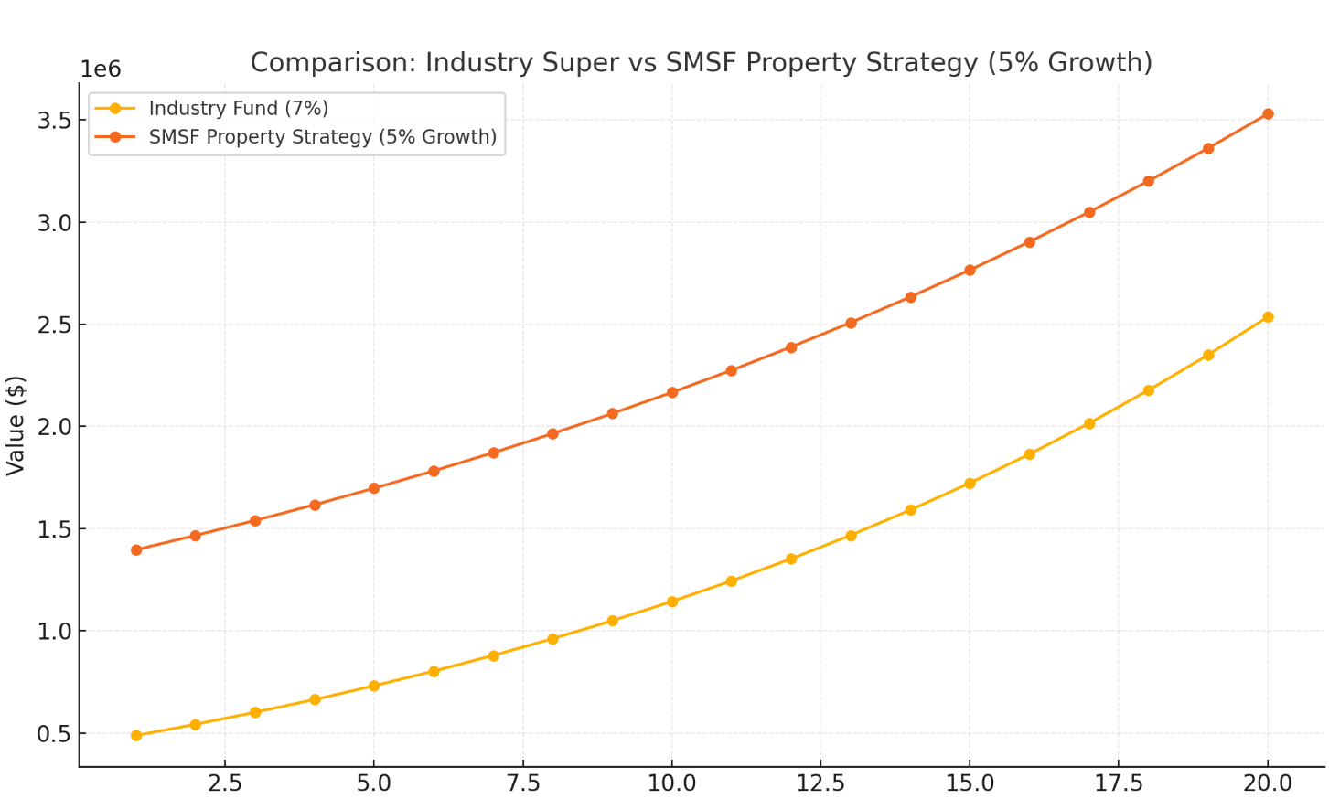

SMSF strategy overtakes industry funds significantly by Year 12–13, and the gap widens as leverage amplifies returns and loan repayments finish.

Key Observations
- Leveraging inside super nearly doubles retirement wealth compared to staying in industry funds, assuming property achieves 5% p.a. growth and no major market shocks.
- Loan repayment is completed within 17 years using contributions and rental income, after which cash builds rapidly.
- Property strategy benefits from:
  - Compound capital growth on a larger asset base (due to leverage)
  - Tax advantages inside SMSF (rental income and contributions taxed at 15%, and 0% in pension phase)
- Remaining in industry funds provides:
  - Liquidity and diversification
  - Lower compliance burden and risk compared to SMSF

Risks & Considerations
✔ Pros:
- Potential to achieve $1.4M more at retirement
- Tax efficiency
- Diversification from shares-only portfolio
- Rental Yield paid directly to superfund to assist with loan repayments
✘ Cons:
- Liquidity risk (property ties up capital; hard to exit quickly)
- Loan repayment reliance (on rental income + contributions)
- Market risk (property values may stagnate or fall)
- Compliance and costs (SMSF setup, audit, loan fees)
- CONSIDERATION of children – by using the SMSF strategy family and friends are unable to use the property.

Strategic Recommendations
- Confirm borrowing capacity and LRBA feasibility with lender and SMSF specialist.
- Property selection is critical: Choose high-demand suburb with strong fundamentals (low vacancy, infrastructure growth).
- Maintain liquidity buffer (retain some cash in SMSF to cover shortfalls).
- Insurance review: Ensure adequate cover in SMSF or personally to protect contributions continuity.
- Ongoing monitoring: Annual SMSF audit, rental yield assessment, and portfolio review.
- CONSIDERATION of children – by using the SMSF strategy family and friends are unable to use the property.

Work Test

From 1 July 2022, a super fund can accept any contributions made for a member while they are under the age of 75 (including the period up to 28 days after the end of the month in which they turn 75), regardless of their work status.

Superannuation – Pension Phase and Retirement Income Streams

Upon reaching preservation age, current legislation allows you to commence an income stream with your superannuation monies. From age 60, all income received from this income stream is tax free.

Once you have commenced an income stream all income earnt from the amount funding the income stream is also tax free, as opposed to being taxed at 15% when in accumulation phase. Income that is taxed within the super fund includes distributions and any capital gains realised via the selling of units.

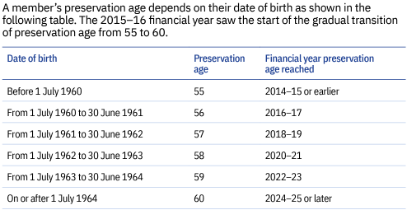

For Consideration:

- The minimum income stream that must be drawn from the Allocated Pension is:

Age | Under 65 | 65-74 | 75-79 | 80-84 | 85-89 | 90-94 | 95+
Standard percentage | 4% | 5% | 6% | 7% | 9% | 11% | 14%

What is paid to your adviser

Plan Fee
As part of the recent Zurich Trauma Insurance claim, you are entitled to an additional Financial Planning benefit of $3,000 which covers most of the fee for this Statement of Advice.

The total plan fee accumulates to $5,000 + $500 GST = $5,500.

I am an authorised representative of Pareto Group Pty Ltd (ABN 11 155 278 078), which holds an Australian Financial Services Licence (AFSL #418700).

Disclosure Statement

To help you understand the full benefits, details and risks of our recommended products, please read the Product Disclosure Statements that we will provide you.

Please let us know if you have any questions.

Cooling-off periods

After investing in a financial product, you have a “cooling-off” period in which to change your mind if you don’t think the product meets your needs. The cooling-off period usually starts when you’re told the product has been set up. The length of the period varies with each product.

Each Product Disclosure Statement explains your cooling-off rights.

If you wish to cancel a product, please tell us in writing so we can contact the product issuer within the time restrictions.

No guarantee

The investments we recommend for you must be appropriate for you. However, we don’t guarantee they’re the best available or that they’ll perform in a particular way. Product performance depends on the features and risks described in the Product Disclosure Statements given to you.

Please take the time to read the PDS and understand the products we have recommended. If you have any questions, please contact us.

Tax

There will be tax implications if you act on this advice. We recommend you ask a tax professional to assess the impact on your short and long-term financial positions.

Are My Product Recommendations Restricted?

Non-Superannuation Products

Yes, when making non-superannuation product recommendations I can only choose products from our Approved Product List (APL). This list is compiled by a dedicated Investment Committee, made up of Research Manager, Directors and Representatives who carefully analyse investment products, prior to including any product on the APL. The Committee utilises leading industry research houses to assist with their analysis.

The APL is regularly reviewed to ensure that all funds, managers and investment companies continue to meet our ongoing stringent requirements.

Superannuation Products

Yes, when making superannuation product recommendations I can only choose products from our Approved Product List (APL). However, if you have a superannuation product that is not on our APL, I am still able to make recommendations in relation to that fund providing I have conducted the necessary research and have a thorough knowledge of the fund.

What is My Responsibility to You?

I am responsible for providing you a ‘clear, concise & an effective’ method of communicating my recommendations to you. The recommendations are based on your goals and objectives, personal and financial situations, and other information collected from you. The recommendations are appropriate for your needs and current situation.

As the SoA is specifically prepared for you and based on your situation, I do not take any responsibility for any third-party persons acting on all or on a part of any advice or recommendations made in this SoA.

Do I Guarantee the Investments I have recommended?

No. By law, the investments I have recommended must be appropriate to you, however, I do not guarantee that the recommended investments are the best for you or that they will perform in a certain way.

Your Financial Plan

In preparing this plan we have taken into account your specific goals and objectives, and have designed an appropriate strategy that aims to accomplish these.

It is import to appreciate that we live in an ever-changing world. Accordingly, it is probable that, overtime, the basis of our calculations (inflation rates, investment rates etc) will change, as will your own requirements and expectations. It is therefore recommended you review your plan on a regular basis to ensure you are still on track to achieve investment objectives.

It is essential to have your investment portfolio reviewed to ensure that the investments are working to their maximum potential and any changes to the investment markets, taxation etc. are promptly and correctly responded to.

Next steps

How to get started

To implement our recommendations in this plan, please do the following:

- Make sure you read this Statement of Advice and Product Disclosure Statements (if applicable)
- Contact us if you have any questions
- Tell us immediately if any information is incorrect

Finally

Please note, as with any investments, their future value may fluctuate, particular rates of return cannot be guaranteed and you may not get back what you originally invested. We have provided a brief summary of the managed investment products recommended, however, you will need to study the investment statements of the recommended products carefully before you decide to invest.

Appendix A – Assumptions
In preparing your financial strategy, it is necessary to make certain assumptions. These are outlined below.

- Current superannuation rules, taxation legislation and social security rates have been used;
- Where applicable Medicare Levy of 2.0% is included on marginal tax rates;

